|  |  |  |  |
| --- | --- | --- | --- |
|  |  |  |  |
|  |  |  |  |
| NAME | | | |
| LOCATION | | | |
| DATE | | GRADE | |
| NO. OF SPECIES | TOTAL SCORE | | |
|  |  |  |  |
|  |  |  |  |
| **A SCALE 340g +1% WT** | | **PTS** | **WT** |
| Flounder / Sole | (23cm min) | 125 |  |
| King George Whiting | (27cm min) | 125 |  |
| Yellow Eye Mullet |  | 125 |  |
|  |  |  |  |
| **B SCALE 400g +1% WT** | | **PTS** | **WT** |
| Flathead (All species) | (27cm min) | 100 |  |
| Horseshoe Leather Jacket | | 100 |  |
| Sea Sweep | (23cm min) | 100 |  |
| Six Spined Leather Jacket | | 100 |  |
| Snook | (30cm min) | 100 |  |
| Squid |  | 100 |  |
|  |  |  |  |
| **B SCALE BONUS 400g +1% WT** | | **PTS** | **WT** |
| Bream (All species) | (28cm min) | 125 |  |
| Rock Ling | (30cm min) | 125 |  |
| Salmon | (21cm min) | 125 |  |
| Snapper | (28cm min) | 125 |  |
| Trevally | (20cm min) | 125 |  |
|  |  |  |  |
| **C SCALE 500g +1% WT** |  | **PTS** | **WT** |
| Banded Morwong | (23cm min) | 100 |  |
| Boarfish (All species) |  | 100 |  |
| Trumpeter |  | 100 |  |
|  |  |  |  |
| **D SCALE 20cm + 1pt/cm extra** | | **PTS** | **LGTH** |
| Garfish |  | 125 |  |
|  |  |  |  |
| **E SCALE +1% WT** |  | **PTS** | **WT** |
| Crayfish (All species) | (11cm min) | 125 |  |
|  |  |  |  |
| **UNLISTED - MAX 2 SPECIES 500g +1% WT** | | **PTS** | **WT** |
|  |  | 150 |  |
|  |  | 150 |  |
|  |  |  |  |

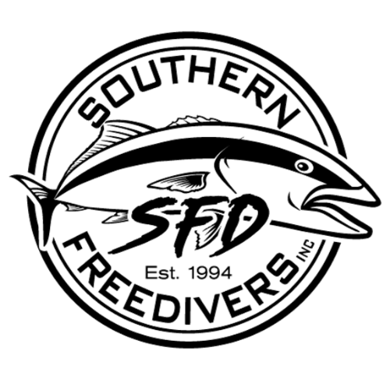

|  |  |  |  |
| --- | --- | --- | --- |
| **JUNIORS ONLY** | | | |
| **MIN +1% WT** | **MIN** | **PTS** | **WT** |
| Magpie Perch | 400g | 100 |  |
| Blue Throat Wrasse (28cm min) | 500g | 100 |  |
| Zebra Fish | 500g | 100 |  |
| Dusky Morwong | 1000g | 100 |  |
|  | | | |
| * All fish captured must comply with Victorian Recreational minimum legal size and bag limits. * Should any competitors fish presented for weighing be twenty percent (20%) or more below the minimum weight/length a 50-point penalty will apply. * Only 1 fish from each species to be presented in the weigh-in area. A 50-point penalty will apply for each extra fish. * Juniors can present any species on the score sheet to weigh in, including the “Juniors Only” species. * Seniors cannot present the "Juniors Only" species to weigh in. A 50-point penalty will apply for each Juniors fish presented. * "Unlisted" signifies any species not on the score sheet that is not listed in the Club Series Rules as ineligible to be weighed. * Up to 2 unlisted species can be weighed in. They cannot be 2 of the same species. * Crayfish cannot be used for burley. * Refer to the Southern Freedivers Club Series Rules for all rules and details of eligible species. | | | |
|
|
|
|
|
|
|
|
|
|
|
|
|
|
|
|
|
|